**WiKi Site**

目录：

Home Page：…………………………………………………………………………………………………… . 2

Introduction: ……………………………………………………………………………………………………… 2

Technology…………………………………………………………………………………………… 2

Background…………………………………………………………………………………………. . 2

Performance indicators………………………………………………………………………… 3

Development: ……………………………………………………………………………………………………… 3

2013-2017…………………………………………………………………………………………… 3

2018-2020…………………………………………………………………………………………… 4.

2021……………………………………………………………………………………………………… 4

2022………………………………………………………………………………………………………. 5

The key technology: ………………………………………………………………………………………………5

Application field：………………………………………………………………………………………………….6

**WiKi Link:** <https://da16e1.baklib-free.com/>

**Home Page:**

This page shows the overall site, so that visitors can understand the content of the site and smoothly find the content they want.

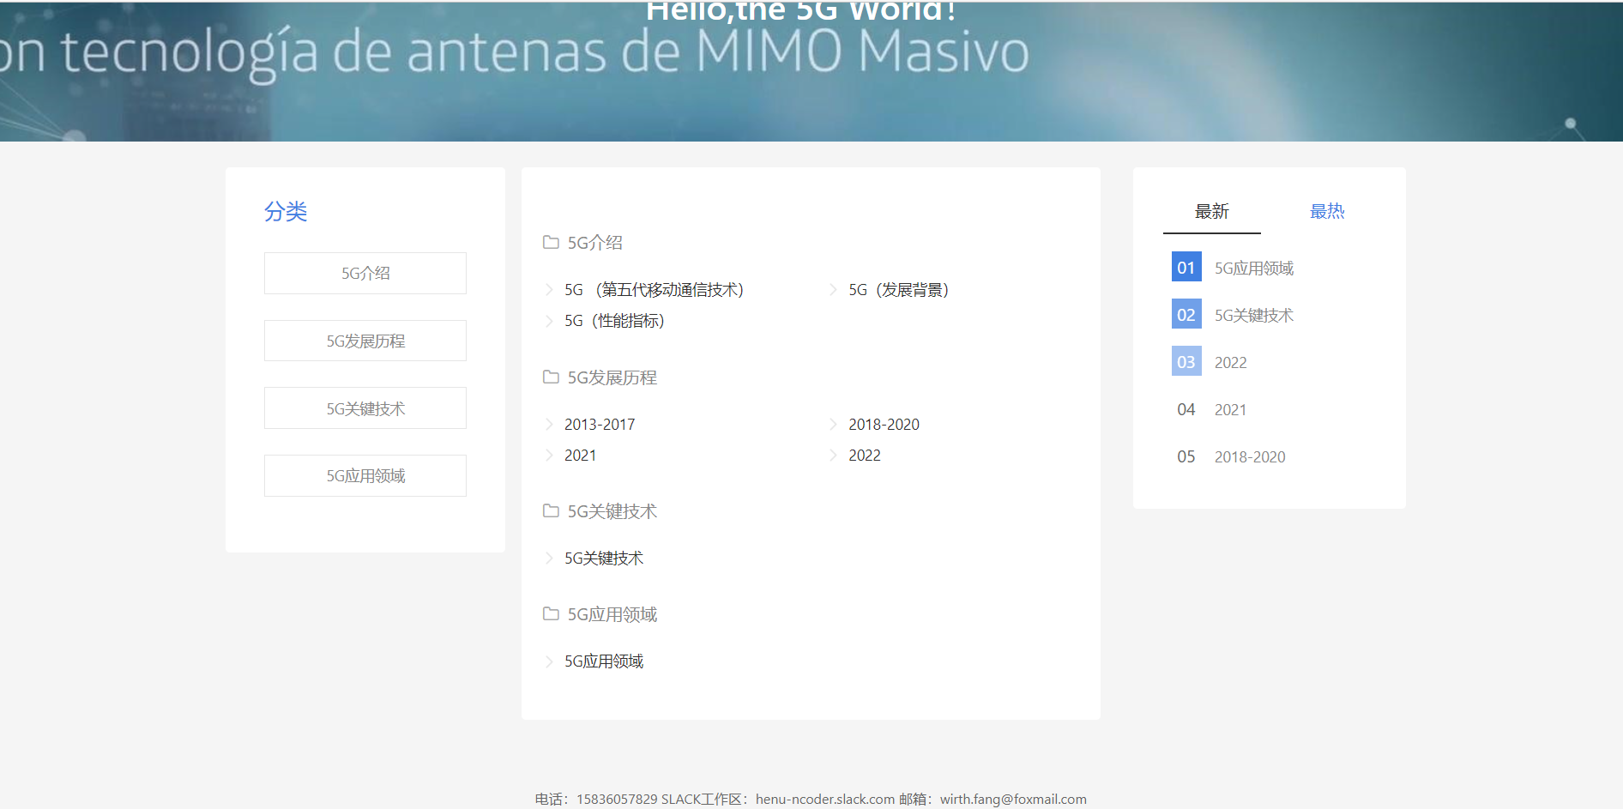

**Introduction:**

This section will provide a more detailed introduction to 5G to help visitors understand it.

Technology

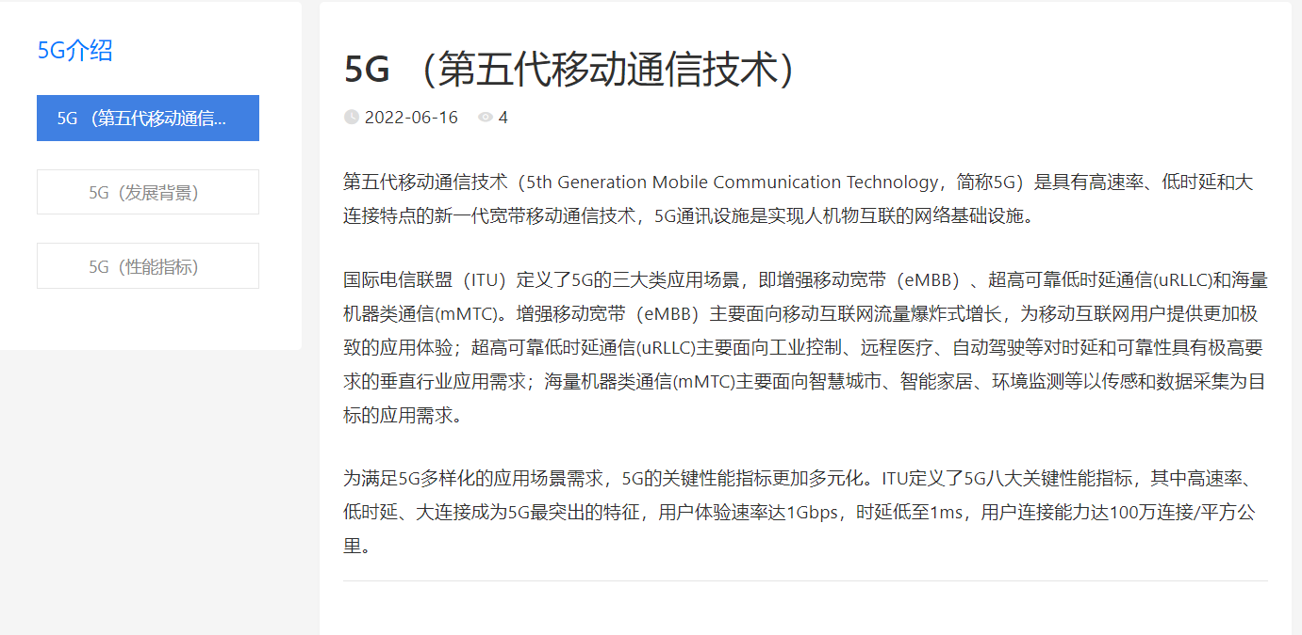

Background

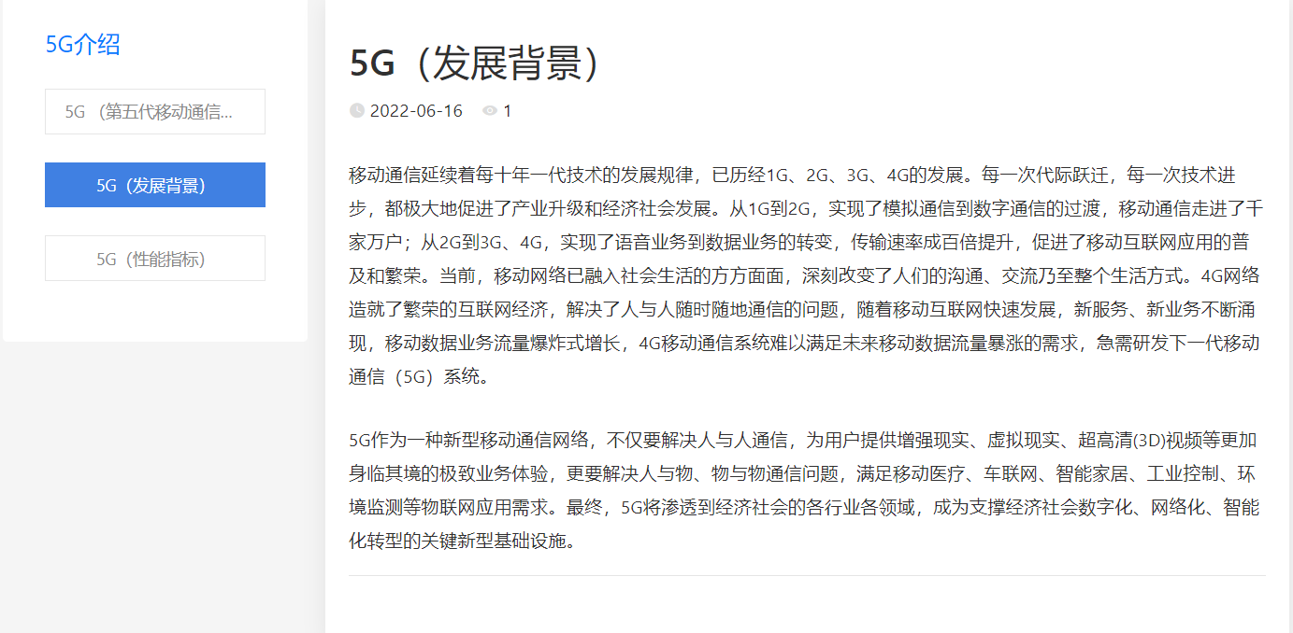

Performance indicators

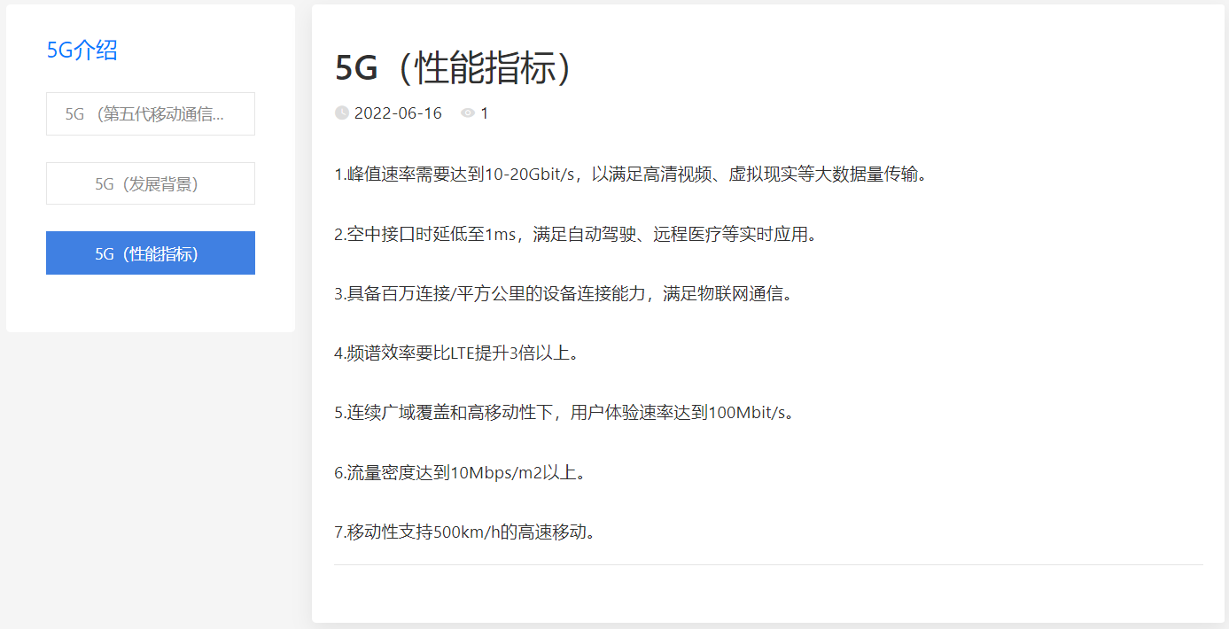

**Development:**

2013-2017

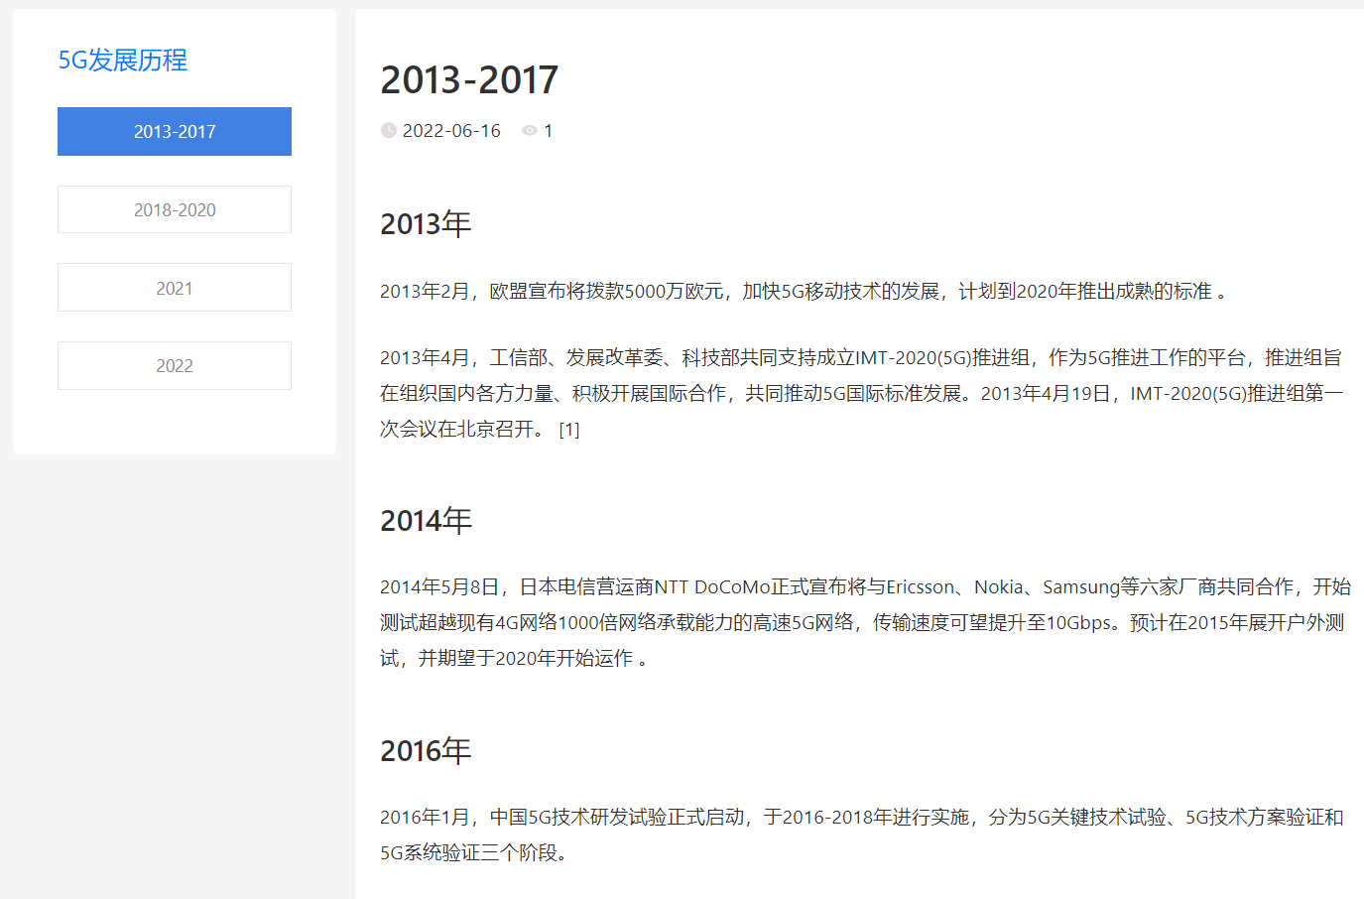

2018-2020

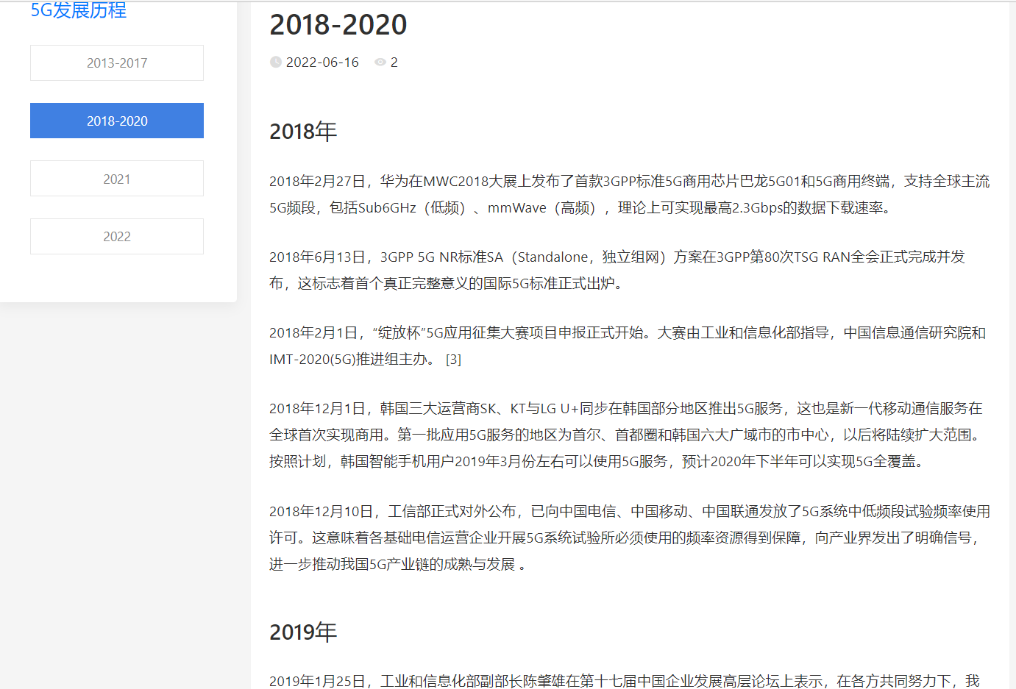

2021

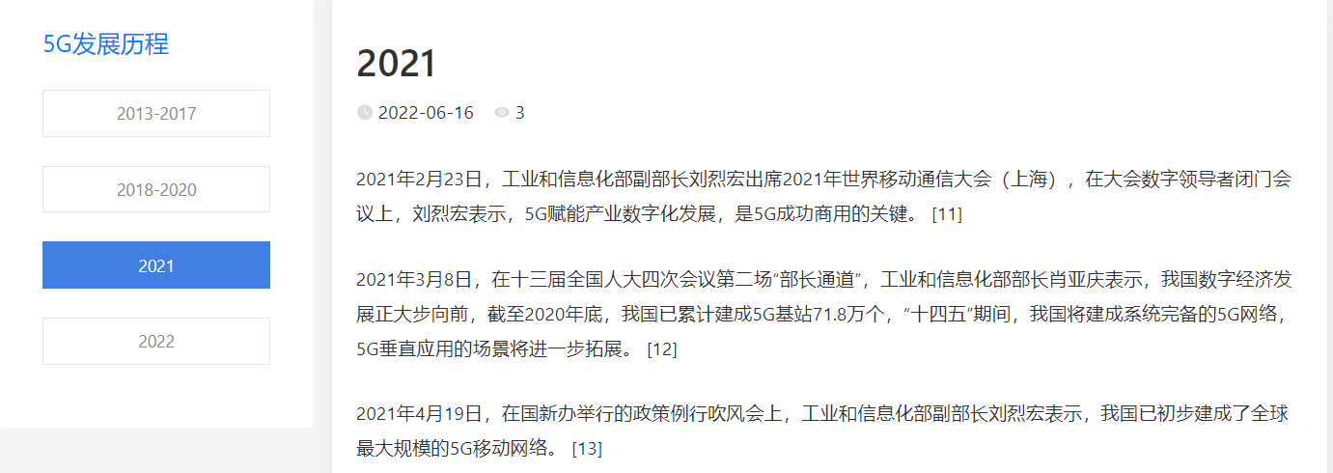

2022

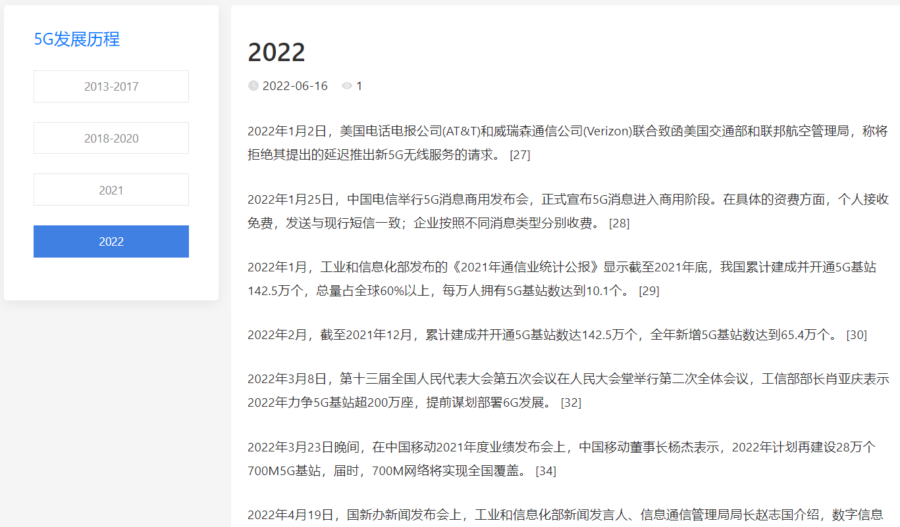

**The key technology:**

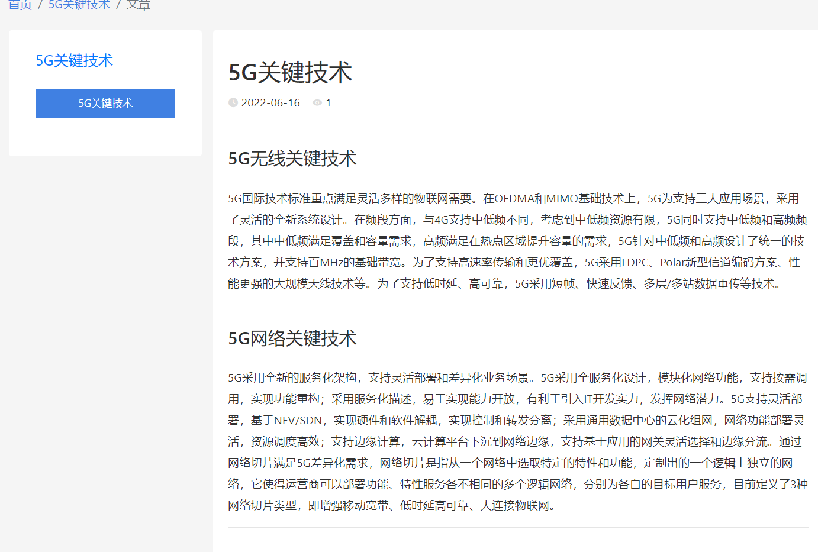

**Application field**

